**Part 2**

**Inter-Symbol Interference due to multi-path channels**

* multiple copies of the signal would travel around and reach the receiver at different times. This effect is what is known as the multipath effect.
* To avoid this phenomenon, we need to reverse the multipath channel effect at the receiver.
* multipath channel effect is distributed exponentially decreasing.

**TX:**

* BPSK symbols with energy Eb = 1.
* Square pulses (1, -1).

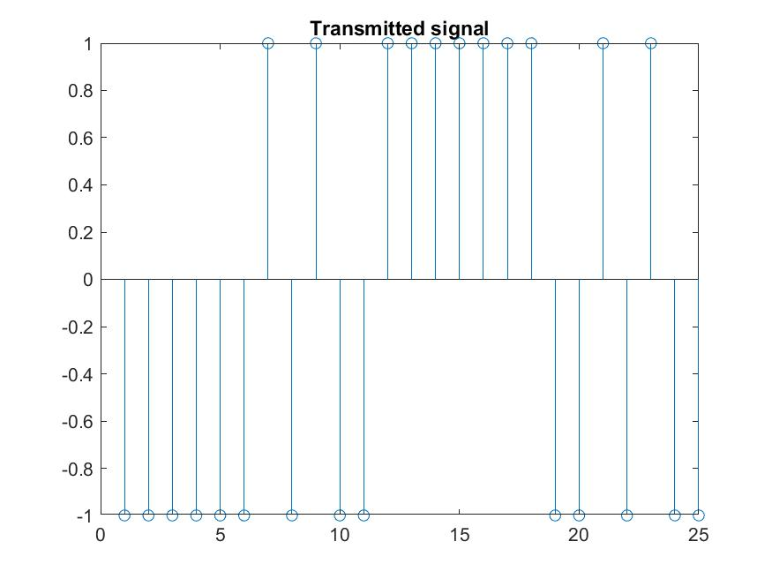

**Channel:**

* Multi-path channel effect.

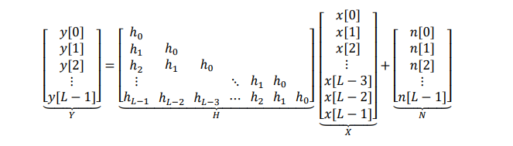

* AWGN effect with zero mean and variance 1.

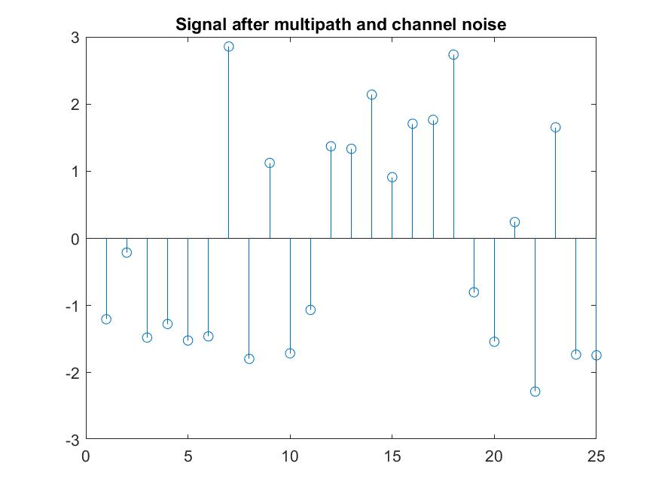

**RX:**

* Equalizer to reverse the multi-path channel effect.
* AWGN can’t be reversed.
* Simple detector

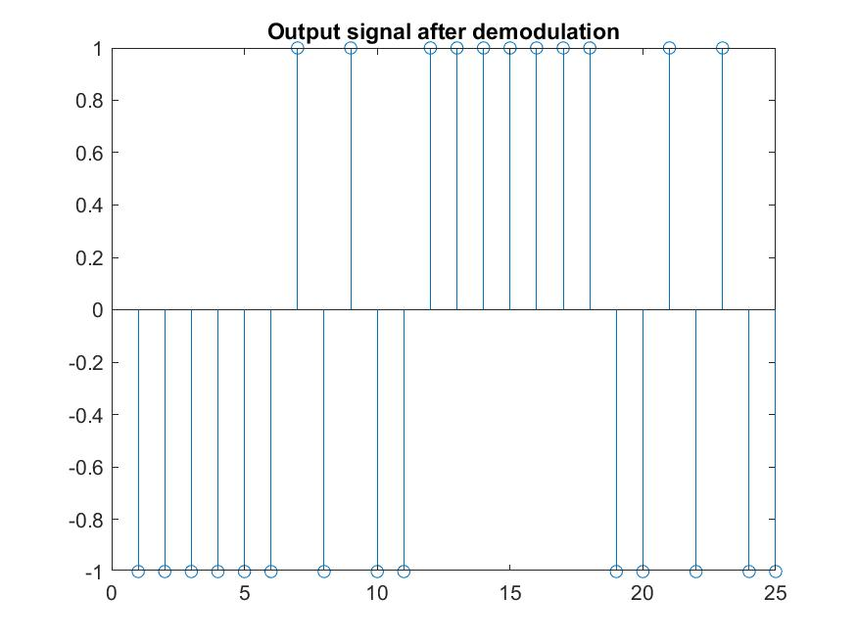

What is the best way of estimating the transmitted symbols 𝑿?

Square pulses then reverse the multi-path channel effect by equalizer which is an inverse for the multi-path matrix.

**BER vs Eb/No(dB):**

